**CHAPTER ONE**

**INTRODUCTION**

A Customer Relationship Management (CRM) system is a technology-driven solution designed to help businesses manage and optimize their interactions with customers. It serves as a centralized platform for collecting, organizing, and analyzing customer data, providing insights that enable personalized communication, streamlined processes, and improved customer experiences. CRM systems play a pivotal role in fostering long-term relationships, enhancing customer satisfaction, and supporting various business functions such as sales, marketing, and customer service.

* 1. **Background of the Study**

The background of the study includes; The **Historical background, Conceptual background, Theoretical background and Contextual background** of a CRM system

**1.11) Historical Background**

Customer Relationship Management (CRM) systems have evolved significantly over the years, playing a crucial role in shaping the way businesses manage and interact with their customers. The historical background of CRM systems traces back to the late 20th century when businesses recognized the need for more organized and effective ways to manage customer relationships.

The roots of CRM systems can be traced back to the 1980s when businesses started using database marketing to store and manage customer information. This marked the initial steps towards a more systematic approach to customer relationship management. The focus was primarily on maintaining accurate customer data for marketing and sales purposes.

The 1990s saw the emergence of contact management systems, which laid the foundation for modern CRM. These systems allowed businesses to centralize customer information, including contact details, interactions, and purchase history. However, these early systems were often limited in scope and lacked the comprehensive features of contemporary CRM platforms.

As technology advanced, so did CRM systems. The early 2000s witnessed a shift towards integrated CRM solutions that combined various aspects of customer management, including sales, marketing, and customer service. This integration aimed to provide a holistic view of customer interactions across the entire business, facilitating more informed decision-making.

The mid-2000s marked a significant milestone with the advent of cloud-based CRM systems. This development allowed businesses to access and manage customer data from anywhere, fostering greater flexibility and collaboration among teams. Additionally, the integration of mobile devices further extended the reach of CRM systems, enabling real-time updates and interactions on the go.

The latter part of the 2000s and early 2010s witnessed the integration of social media into CRM systems. Businesses recognized the importance of monitoring and engaging with customers on platforms like Facebook and Twitter. This integration not only expanded the channels for customer interactions but also provided valuable insights into customer preferences and sentiments. With the increasing volume of data generated by customer interactions, CRM systems evolved to incorporate advanced analytical capabilities. Big data analytics became an integral

part of CRM, empowering businesses to derive meaningful insights from vast amounts of customer information. This, in turn, enabled more personalized and targeted marketing strategies. In recent

**1.12) Conceptual Background**

In this review of a Customer Relationship Management System, we are to explain in details the concepts used in our topic such as defining some key terms that will be used throughout this project.

* Customer: The customer is the main reason why we are creating the system in the first place. The customer is key. A customer is a person who is interested in purchasing a particular good or service either for consumption or for sale.
* Lead: A lead is a potential customer. A lead could be someone who is interested in purchasing a particular service or good that needs some convincing into actually purchasing that good or service. Once the lead purchases that particular good or service, he or she is now considered to be a customer.
* Relationship: A relationship could be a specific kind of interaction that occurs between two or more people. The relationship between two things or people depends on how they interact with one another.
* Management: Management is how a company or organization direct workflow, operations, and employees in order to meet up with the company goals. In this case, we are building a system that will help a company do all the management without having to do much physical work
* Retention: This is the ability of a company to be able to maintain a long-term relationship between them and their client. Retaining customers is more cost efficient than getting new customers, plus, the retained customers could always help advertise your business to friends and family if you are able to retain and manage them correctly. We now see that by retaining the customer, you can also get referrals from them, hence more customers

**1.13) Theoretical Background**

Most of the theories here are based on ideas based on the work of numerous authors. These theories provide different perspectives on how organizations can approach and manage customer relationships, and the references listed can serve as starting points for further exploration. Barton Goldenberg said “CRM as an integral information system that helps organizations manage customer relationships by providing a comprehensive view of customer interaction” (Goldenberg, B. (2003). CRM Automation. Prentice Hall.). The relationship Marketing theory as per Leonard Berry, Jagdish Sheth, and others stated that “CRM emphasizes long term value of customer relationships and the importance of building and maintaining strong connection with customers”. (Berry, L.L., Sheth, J.N. (2008). Relationship Marketing. Sage Publications). Furthermore, Paul Greenberg in 2001 said that “CRM focuses on how technology, particularly CRM software enables customer interactions. (Greenberg, P. (2001). CRM at the Speed of Light: Capturing and Keeping Customers in the Internet Real Time. McGraw-Hill.). The Social CRM theory was later made by Brent Leary, and Paul Greenberg which was an update to what Paul Greenberg made back in 2001. This theory states that “CRM extends traditional CRM by incorporating social media and networking tools in order to engage customers in a more interactive and collaborative manner. (Leary, B., & Greenberg, P. (2010). CRM 2.0 – The New Rules of Customer Relationship Management. Pearson Education. The Customer-Centric theory, made back in 2004 by Don Peppers and Martha Rogers which states that “CRM advocates for a customer-Centric approach where the entire organization is aligned to meet customer needs and expectations. (Peppers, D., & Rogers, M. (2004). Managing Customer Relationships: A Strategic Framework. Wiley.). Another theory called the One-to-One Marketing Theory which was made by Don Peppers and Martha Rogers again back in 1994 states that “CRM proposes personalized and customized marketing strategies tailored to individual customer preferences and behaviors. (Peppers, D., & Rogers, M. (1994). The One-to-One Future: Building Relationships One Customer at a Time. Currency).

**1.14) Contextual Background**

The contextual background of Customer Relationship Management (CRM) systems encompasses the external factors, industry dynamics, and organizational considerations that influence the design, adoption, and effectiveness of CRM strategies and systems. Understanding the contextual landscape is crucial for businesses seeking to implement CRM solutions that align with their specific needs and the broader environment in which they operate.

The contextual background of CRM systems is deeply intertwined with industry dynamics and the competitive landscape. Industries with high competition and rapidly changing market conditions often necessitate robust CRM strategies to differentiate businesses and build lasting customer relationships. The contextual factors here include the level of competition, market trends, and the need for businesses to stay agile in response to evolving customer expectations.

The size and structure of an organization play a significant role in shaping the context of CRM implementation. Large enterprises may require scalable CRM solutions that can handle vast amounts of customer data and complex workflows. In contrast, small and medium-sized enterprises may focus on more streamlined CRM systems that suit their specific needs and resources. The organizational structure also influences how different departments (sales, marketing, customer service) interact with and benefit from CRM.

The regulatory environment and data privacy considerations are integral to the contextual background of CRM systems. Industries with strict data protection regulations, such as healthcare or finance, demand CRM solutions that comply with these standards. The contextual factors here include legal requirements, industry-specific regulations, and the need for businesses to prioritize data security and privacy in their CRM practices.

The technological landscape in which an organization operates greatly influences CRM decisions. The contextual background considers the existing technological infrastructure, including legacy systems and the readiness for digital transformation. Successful CRM implementation requires seamless integration with existing technologies to ensure data flow, accessibility, and compatibility across the organization.

For businesses operating in a global context, CRM strategies need to be culturally sensitive and adaptable. The contextual background includes considerations of diverse customer segments, languages, and cultural nuances. An effective CRM system should support businesses in managing relationships with customers from various cultural backgrounds, ensuring that communication and marketing efforts resonate across diverse markets.

* 1. **PROBLEM STATEMENT**

It is of utmost importance for a business to be able to keep track of their customers and maintain a relationship with them in order to build trust which can go a long way in helping the business retain its customers. Some of the difficulties encountered include:

* The unordering of customer information
* Inability to deliver on the expected end product due to lack of sufficient communication between the sales team members of that organization.
* Lack of trust
* Insufficient communication between the business and the customer
* Difficult to convert **Leads** into **Customers**
  1. **OBJECTIVES OF THE STUDY**
     1. **Main Objectives**

By the end of this work, the researcher will design a Customer Relationship Management (CRM) System which’ll help businesses manage customer data correctly in order to help the business complete customer tasks and requests quickly and efficiently, build trust and loyalty with the customers by constant communication and check-ins, etc., and improve customer retention

* + 1. **Specific Objectives**

The studies include implementing this Customer Relationship Management System with the use of web application software and technologies such as HTML, CSS, JavaScript, PHP, Xampp, and many others in order to be able to ensure the effective rendering of the services being required by the customers.

Specific objectives of the web application include:

* Increase customer loyalty and retention by understanding and addressing individual customer needs and preferences.
* Enhance customer service by providing quick access to customer information, enabling prompt issue resolution, and improving overall customer satisfaction.
* Facilitate efficient acquisition of new customers through targeted marketing strategies and personalized interactions.
* Facilitates the conversion of potential customers(leads) into customers.
* Deliver personalized experiences by tailoring interactions based on customer data, leading to increased engagement and brand loyalty.
* Facilitate seamless communication between different departments within an organization, fostering a collaborative approach to customer relationship management.

**1.4) RESEARCH QUESTIONS**

**1.4.1) General research questions**

Can putting in place a Customer Relationship Management System be an effective method for solving the problems mentioned above?

**1.4.2) Specific research questions**

- What are the key factors influencing customer purchasing decisions?

- What should be done in order to retain customers?

- How satisfied are customers with the products/services and overall experience?

- What factors contribute to customer loyalty, and how can they be enhanced?

- How well are sales teams utilizing CRM data to nurture leads and close deals?

- How efficient is the current customer service process in addressing and resolving issues?

- What common issues do customers face, and how can they be preemptively addressed?

**1.5)** **HYPOTHESIS OF STUDY**

Hypotheses are tentative solutions given to the research questions. These hypotheses guide research questions and provide a framework for empirical testing. These hypotheses typically articulate the expected outcomes or relationships between different elements within the CRM system or between the system and organizational performance.

**1.5.1) Specific Hypothesis**

Higher levels of personalized communication and targeted marketing, facilitated by the CRM system, will positively correlate with increased customer satisfaction and loyalty.

The implementation of advanced analytics and segmentation features in the CRM system will result in more effective marketing campaigns, leading to improved customer engagement and higher conversion rates.

The integration of the CRM system with sales processes will lead to a more streamlined and efficient sales cycle, resulting in increased sales conversions and revenue.

Adequate training programs and user-friendly interfaces within the CRM system will positively influence user adoption rates among employees, enhancing overall system proficiency and effectiveness.

Regular data quality checks and maintenance protocols within the CRM system will contribute to higher accuracy and integrity of customer data, positively impacting decision-making and strategic planning.

Improved integration capabilities between the CRM system and other organizational tools will result in smoother data flow and enhanced communication between different departments, contributing to a more cohesive and informed business operation.

Stringent security measures implemented within the CRM system will lead to increased customer trust and compliance with data protection regulations, minimizing the risk of data breaches.

The CRM system's ability to provide quick access to customer information will positively impact customer service efficiency, resulting in faster issue resolution and heightened customer satisfaction.

Seamless integration of customer touchpoints through the CRM system will contribute to a consistent and unified customer experience across various channels, enhancing brand perception and loyalty.

The successful implementation and utilization of the CRM system will demonstrate a positive correlation with measurable returns on investment, as evidenced by increased customer acquisition, retention, and overall business growth.

**1.6) SIGNIFICANCE OF THE STUDY**

The study will bring about a change in the way businesses handle their customers efficiently in order to:

* Manage customer data correctly in an organized way, provide easy access to customer data and prevent the loss of data too.
* Deliver on the customer’s expectations.
* Build trust and loyalty.
* Convert Leads into Customerseasily

**1.7) JUSTIFICATION OF THE STUDY**

I implement this system to help businesses easily grow by helping them easily retain their customers by building trust and communication between the customers and the business. This system is going to be used mostly by the business implementing it, but the customers will have a less sophisticated view of the system where they will be able to log in and check their project progress, lay updates and complaints about their project and those complaints will be received by the project manager and his team and they will be able to correct the project to the customer’s taste.

**1.8) SCOPE OF THE STUDY**

The scope of the study here involved **time, geographic, and thematic scope**

**1.8.1) THEMATIC SCOPE**

The project is titled a Customer Relationship Management System (CRM system) which is totally built with administrative ends and only the administrator is given access to create, edit, and delete things.

**1.8.2) GEOGRAPHIC SCOPE**

This project was carried out in the political capital of Cameroon, Yaoundé, precisely at maison Damas at Timely Performance Care Center (TPCC)

**1.8.3) TIME SCOPE**

This project (CRM system) took 3 months, from 29th July to 29th August. However, this period wasn’t sufficient to carry out scientific research.

**1.9) ORGANIZATION OF STUDY**

* Chapter one which comprises of the general introduction, the background of study, problem of the statement, objective of the study, research questions, hypothesis, significance of study, justification and scope of study.
* Chapter two is concerned with the literature review which contains the theoretical review, conceptual review and empirical review
* Chapter three looks at the research methodology which includes the research design of the Customer Relationship Management System, data instrument analysis and interpretation.
* Chapter four is based on data presentation analysis and presentation.
* Chapter five is on the recommendation for future implementation and conclusion.

**CHAPTER TWO: LITERAL REVIEW**

In this chapter, we are going to be seeing the following. Firstly, review by concepts, secondly, review by objective, and finally, presentation of internship activities.

**2.1) THEORETICAL REVIEW**

Customer retention is a critical component of business success, and Customer Relationship Management (CRM) systems play a pivotal role in facilitating and enhancing retention strategies. This theoretical review aims to explore the relationship between CRM systems and customer retention, focusing on key theoretical concepts and mechanisms that underpin their interconnection.

At its essence, customer retention involves the ability of a business to retain existing customers over an extended period. The theoretical foundation of CRM in relation to customer retention is rooted in relationship marketing theories, emphasizing the shift from transactional interactions to building long-term, mutually beneficial relationships with customers.

The first theoretical underpinning is the concept of customer loyalty. CRM systems provide businesses with the tools to collect, analyze, and interpret customer data, enabling a deeper understanding of customer preferences, behaviors, and needs. By leveraging this information, organizations can tailor their products, services, and interactions, fostering a personalized experience that enhances customer satisfaction and loyalty.

The second theoretical framework centers on the customer journey. CRM systems track customer interactions across various touchpoints, allowing organizations to create a seamless and consistent experience throughout the entire customer lifecycle. This continuity in engagement contributes to a positive customer experience, influencing their decision to remain loyal to a brand.

The third theoretical aspect is the role of effective communication in customer retention. CRM systems facilitate targeted and personalized communication strategies, ensuring that customers receive relevant information, offers, and support. Timely and relevant communication builds trust, reinforces the customer's sense of value, and increases the likelihood of them staying with the brand.

Moreover, the theoretical perspective of customer lifetime value (CLV) is crucial in understanding the long-term impact of CRM on retention. By predicting and maximizing CLV, businesses can allocate resources effectively, focusing on retaining high-value customers and optimizing their overall profitability.

The concept of emotional connection forms another theoretical basis. CRM systems help organizations identify and leverage emotional triggers that resonate with customers, fostering a sense of attachment to the brand. Emotionally connected customers are more likely to remain loyal and act as brand advocates, contributing to sustained customer retention.

2.2) **CONCEPTUAL REVIEW**

Customer Relationship Management (CRM) systems are integral tools for businesses aiming to cultivate lasting relationships with their customers and, consequently, improve customer retention. This conceptual review explores the conceptual framework that underscores the relationship between CRM systems and customer retention, shedding light on key concepts and mechanisms that drive their interconnected success.

Central to the conceptual foundation is the notion of gaining a holistic understanding of customers. CRM systems consolidate diverse data points, including customer preferences, behaviors, and transaction history. This comprehensive customer profile empowers businesses to tailor their products and services to individual preferences, fostering a personalized experience that significantly contributes to customer satisfaction and, consequently, retention.

A crucial conceptual aspect is the ability of CRM systems to map the customer journey. By tracking and analyzing customer interactions across various touchpoints, businesses can identify critical junctures in the customer experience. Understanding the customer journey enables organizations to address pain points, streamline processes, and ensure a seamless experience, all of which are pivotal in retaining customers over the long term.

The incorporation of predictive analytics within CRM systems is a key conceptual driver. By leveraging historical data, businesses can predict future customer behaviors and trends. This predictive capability is particularly relevant to estimating Customer Lifetime Value (CLV), guiding businesses in allocating resources effectively to retain high-value customers. The concept of CLV provides a strategic lens through which organizations can prioritize efforts to maximize customer retention.

The conceptual framework emphasizes the role of proactive communication in customer retention. CRM systems enable businesses to design and implement targeted communication strategies. By delivering relevant and timely information, personalized offers, and responsive customer support, organizations can enhance customer satisfaction, reinforcing loyalty and minimizing the likelihood of customer churn.

Building an emotional connection between the brand and the customer is a pivotal conceptual aspect. CRM systems assist in identifying and leveraging emotional triggers that resonate with customers. Establishing an emotional connection contributes to brand loyalty, as customers who feel a deeper connection are more likely to remain committed to the brand over time.

**2.3) EMPERICAL REVIEW**

The empirical review of customer relationship management (CRM) systems suggests that businesses using CRM systems are able to retain more customers compared to those not using CRM systems. Several studies have found that the implementation of a CRM system led to improved customer satisfaction, loyalty, and increased customer lifetime value.

Chen and Popovich (2003) found that businesses using CRM systems were able to increase their sales and profitability, indicating that CRM systems can contribute to customer retention by enhancing the overall customer experience. Additionally, Reinartz et al. (2004) found that CRM systems helped businesses identify and target high-value customers, leading to increased customer retention.

Overall, the empirical evidence supports the effectiveness of CRM systems in improving customer retention. Businesses using CRM systems are better equipped to understand customer needs and preferences, leading to more targeted marketing efforts and higher customer engagement. This, in turn, contributes to improved customer satisfaction, loyalty, and ultimately, customer retention.

**2.4) REPRESENTATION OF THE ENTERPRISE**

**2.4.1) PRESENTATION OF INTERNSHIP ACTIVITIES**

In the presentation of the internship activities, it includes the description of the internship place and the internship activities.

**2.4.2) ACTIVITIES CARRIED OUT**

So, during the period of internship, the researcher worked not just on his research but practically implemented some things which were not practically thought in school. The researcher studied programming languages such as JavaScript, Python, and C programming which wasn’t practically studied in school.

* The researcher learnt how to install WordPress and how web pages are created using WordPress.
* The researcher also learnt how to create web pages using HTML, CSS, Bootstrap, and JavaScript for responsiveness.
* Also, the researcher learnt how to create categories for a platform and implementing JavaScript format.
* The researcher also learned and acquired skills in graphics design and digital marketing.

**2.4.3) INTERNSHIP EXPERIENCE**

The researcher’s experience was good as the internship lasted for Three months and learned some programming languages and some extra skills such as graphics designing and digital marketing which expanded my scope.

**2.4.4) STRENGTH AND WEAKNESS**

* **Strength:** Working at Vitna Media gave me lots of experience in the IT field. It is located at Maison Damas and I gained a lot of new found knowledge. These gave the researcher the opportunity to learn and grow entering into the world of IT.
* **Weakness:** A big weakness faced by Vitna Media is its location. The company is hidden behind buildings and is far from the road, which makes it difficult for clients to locate the building. Also, Vitna Media does not have a building of their own, they’re found within a school for autistic children called Timely Performance Care Centre (TPCC) at maison damas.

**2.4.5) PROBLEMS ENCOUNTERED**

One of the main problems encountered here was slow connectivity problems, i.e slow internet services to carry out the normal day to day activities since they mostly advertise their organization through digital marketing. Also, another problem is lack of clients. It is difficult to retain clients due to their prices. Clients usually complained after using their services that it is too expensive for them, which usually makes them seek for alternative measures in advertising their brands. The company doesn’t give their clients enough to trust to want to come back and seek further services from them.

**2.4.6) RECOMMENDATION**

Monthly maintenance of the system to ensure maximum efficiency. There should be more intensity in productivity.

**CHAPTER THREE: METHODOLOGY**

**3.1) INTRODUCTION**

This chapter outlines the methods that will be used to accomplish the project's goal. The steps and evolution of the software development process are terms used to describe the framework in which software is planned, built, and maintained. Here, the emphasis is on the construction process for this application. We will follow this process in order to effectively use the material and method to develop the system.

**3.2) DESCRIPTION OF THE ARCHITECTURE OF THE SYSTEM**

The conception of a good application entails the designer to select the best technology, the appropriate tools, the adapted software necessary and not forgetting to respect the methodology to be used in order to realize the platform and satisfy users with their needs. The architecture of a web application here is talking about an approach to the design and planning of websites that involves technical, aesthetic and functional criteria. As in traditional architecture, the focus is on the user and on user requirements. It also entails employing software, human resources, techniques and information flow in the system. In a typical 3-tiered architecture, users point their browsers to the application server to start using the application. However, the setup of that environment can be considerably more complex than setting up a database for the users to connect to, and making the installer for the client available. 3-tier for users is the most advantageous of these tiers and this is why it has been chosen as our architecture of preference and because 3-tier has the potential of greater speed and METHODOLOGY AND MATERIALS USED 38 securities than the 2-tier architecture. Due to the importance of our web application and the organization in which the information shall flow within the information system, we have chosen the 3-tiers architecture which involved the following points:

• Data are shared on a focal point

• The layout of the application is taken in charge by the computer-client

• Application server also named middleware is the one in charge of providing the resources by calling another server named database server.

The figure below represents a 3-tier architecture where we have the client, database and the application servers which is the choice for our dissertation:

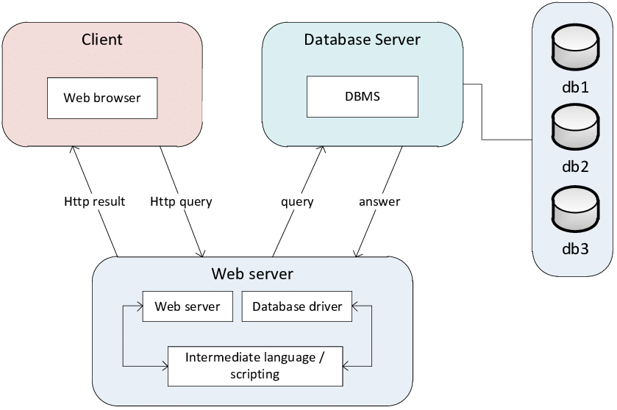

***Figure 1****: Three tier architecture*

**3.3) DATA COLLECTION AND USERS’ NEEDS**

A good web application should take into account the assembly of data collection and users’ needs. It is not possible to realize a web application without studying the information system. So, a good web application should answer the users’ needs with the help of the various methods of 39 data collection put in place. However, the choice of a particular data collection method to be used depends on the objectives the researcher wants to attain at the end. Due to the importance of the project, considering the problem area, a qualitative approach has been chosen to lay down all that is necessary to understand the functioning of the information system of the University of Bamenda related to the automatic generation of students’ diplomas with SMS alert. To do this, two approaches were used: observation and interviews. After having collected the necessary data for the design of our platform, we listed the user's needs.

**3.3.1) OBSERVATION**

We got much inspiration from observation and this of course helped us to have the anxiety to collect data that will help in designing our web application. This was very easy to observe, considering the place where I interned at just by looking at the number of clients who came in during my entire three months of internship. Clients who even came in always came back to the company complaining about how their job was either poorly done or had a lot of errors that could have been easily avoided. At times, the clients would spit it right in their faces saying they won’t be coming back to the company to acquire further services from them. Through the observations, we noticed that the customers and the business were not really in sync when the company was building their projects. There was lack of communication between them because if there was sufficient communication, then all the mistakes made could have been avoided and the outcome would have been much better.

**3.3.2) INTERVIEWS**

The interview started with one of the graphic designers working in at Vitna Media. The conversation was based on how the projects brought in by clients are being carried out. The response was that ‘We simply receive the projects from the clients, and based on the genre of that project, we pass it on to the head of department of that section, then he assigns employees to the project based on the complexity of it and they would carry it out. The clients always come in and leave the project, then we price them accordingly and then give them a rendezvous date to come collect their project or if they would like for it to be sent by mail (for those that were possible to be sent)’. The interviewer saw a very big problem in this response because there was absolutely no communication whatsoever after the client comes in and give the work. That was IT until the day the client is coming to collect the work. The client could always have important changes that could’ve been made or even the project team could have some important questions to ask the customer in order to really make the project up to their standards.

**3.3.3) USERS’ NEEDS**

A relevant web application should be designed according to the user’s needs, a good programmer or developer must not realize a web application without taking into account the users’ needs, thus some considerations have been taken into account. After gathering all the information, we discovered that the company sought suitable, long-lasting solutions to retaining their customers and delivering on quality products that really suits their customer’s taste which are:

* Improve on instant communication
* Build a system that will help them manage their clients and be able to give them promo deals based on their purchase history
* Notify automatically the customers when their product is ready
* Add an interface where clients will be able to see the development of their projects even without them being around it.
* Include a section for reports and complaints where the clients can always lay their complaints based on the developments of their projects.

**3.4) FUNCTIONAL REQUIREMENTS**

The functional specification includes actors which will interact to actually bring out the role of the Customer Relationship Management System and how the application will play this role with the help of its actors which we are to discuss below:

**3.5) FUNCTIONAL SPECIFICATION**

In the functional requirement, we are looking at the various tools used to build up the system.

**3.5.1) ROLES PLAYED BY EACH ACTOR**

**Administrator:**

* Accept or decline projects
* Assign projects to various departments
* Manage everyone else’s account

**Project Team:**

* Handle the project
* Communicate with clients in the system

**Customer:**

* Request for project to be done
* Communicate with the Project team through the system.

**Technical support staff:**

* Handles technical issues of the system
* Assists the Project Team.

**Marketing Professionals:**

* In charge of handling the system’s front end.
* Adds pictures of project in the system so that the customers can see them

**Tracking records:**

* Customer requests/reports sent in the system are stored here

**3.5.2) THE SYSTEM’S ABILITIES**

* The registration of every customer and the above-mentioned actors
* Gathering of customer information
* Progress tab where customers can see their project progress
* Reports tab where customers can lay in reports based on their project’s progress
* A mail and SMS notification system
* Notify customers about promos and also on the completion of their projects
* E-pay via Orange Money (OM), or Mobile Money (MOMO)

**3.6) TECHNICAL SPECIFICATION**

* The home page should present a single login page for each and every actor of the system
* During the connection phase, the platform should present an interface where the Administrator, Customer, and all the other actors can login.
* Once logged in, each user will have their own page with different menus according to the type of user and the privileges they have. For the Administrator, all the menu should be available except the progress and report tab. All these will be displayed according to the physical structure of the web application.
* Just by a click, the administrator can accept or decline incoming project requests from customers who have registered into the platform.

**3.7) NON-TECHNICAL SPECIFICATION**

* **Security level:** This platform should be able to secure users’ information very efficiently and ensure that the information isn’t made public for others to see.
* **User friendly:** The platform should be very interactive, easy to use and easy to navigate since people of all legal ages would be able to access the platform.
* **Availability:** The system should be available to users at any time, anywhere. They just need a computer or a mobile phone and internet connection to access the application.
* **Responsiveness:** This simply means that the platform should be compactible to any device trying to access it such as Desktops, Laptops, Mobile Phones and also tablets.
* **Flexibility and easy access of the platform:** At all times, the web application should be able to respond to any demand by the administrator or the project team.

**Non-Technical specification**

* **Flexible to use:** The web application should be able to track all those who are in the system and the activities being carried out.
* **Performance level:** The internet connection should be very fast with high bandwidth and throughput.
* **Security:** An administrator shouldn’t be able to log into another administrator’s account without prior authorization. Here, each administrator’s account is confidential to them.

**3.8) RESEARCH DESIGN**

Whenever a customer comes in for a service, in a case where there are already several clients, they will have to wait in a queue for the others to leave first before they can be attended to. When the clients come in and say what the need and leave, they don’t often get the end product they really wanted due to insufficient communication between the business and the customer. Also, the customers always scolded the people in charge of their project upon delivery due to a job poorly done. Customer data was so disorganized and there was no way to reach out to the customers after a deal is closed, and because of this, there’s no way to actually keep track of the customers and keep updating them on the new products and promos that are available which can actually be advantageous to them. One thus observes that:

* Lack of communication
* Mis-storage of customer data
* Poor quality of services delivered
* Loss of customers.

So, the Research Design for this web application is coming fortunately to solve those complications.

**3.9) ANALYSIS METHOD**

The researcher is guided by the scientific approach method to create acceptable software, and this method includes an analysis that results in the creation of a web application like this one. Use-case diagrams and use-case details are used to analyze the functional and non-functional requirements in this section. The class diagram, Use Case diagram, and sequence diagram are also included. We will discuss the many sorts of methods, including both object-oriented and functional methods. At the conclusion, we will specify the approach that is ideal for realizing our system and provide the justifications for our decision.

**3.10) OBJECT-ORIENTED MODELING**

Using the object-oriented paradigm throughout the whole development life cycle, object-oriented (OOM) is a popular method for designing applications, systems, and business domains. In contemporary software engineering, OOM is a key approach that is heavily utilized by both OOD and OOA activities.

Under the broad category of object-oriented methods and functional methods, we shall go step by step to examine the many types of methods. At the conclusion, we will specify the approach that is ideal for realizing our system and provide the justifications for our decision.

We can cite the OMT method, UML method, and UP method as examples of object-oriented methods.

**3.10.1) OMT METHOD**

An object modeling approach for designing and modeling software is called the Object Modeling Technique (OMT). Rumbaugh, Blaha, Premerlani, Eddy, and Lorensen created it in 1991 as a technique for creating object-oriented systems and promoting object-oriented programming (ESPINASSE, 1980). OMT was created as a way of constructing software. Rumbaugh cites the following goals for this modeling: Conception (alternative information presentation); Communication with the librarians; Testing physical entities before developing them (simulation);

Decrease in complexity

**3.10.2) UNIFIED MODELING LANGUAGE (UML) METHOD**

UML is a language of modelling unified object in an object-oriented environment developed in

response to the call for the proposal launched by the Object Management Group (OMG) with the

goal of defining the standard notation for the modelling of applications built using objects. The

principal authors of UML are Grady Booch, Ivvar Jacobson and Jim Rumbaugh.

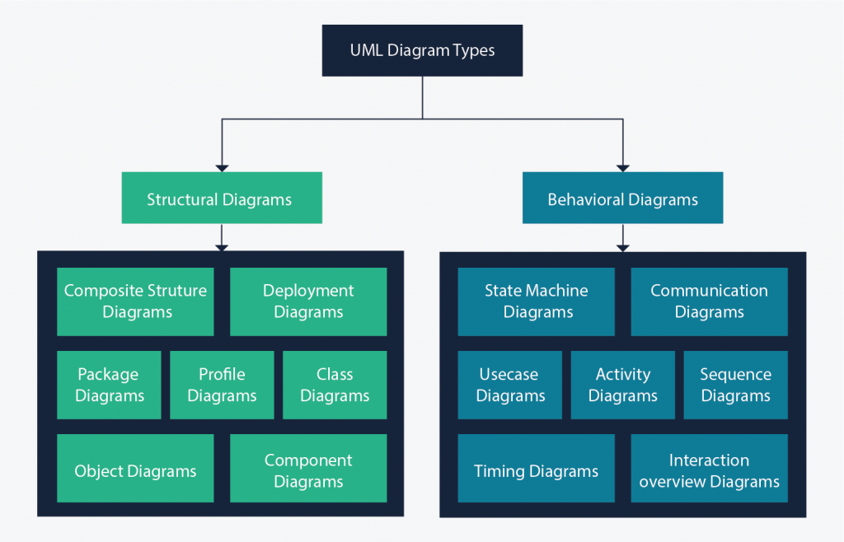

***Figure 2: overview of UML***

**Some advantages of UML are**:

* Formal and standardized language, it allows proceeds of precision and constitutes a pledge of stability. This is what encourages the use of the tools;
* Powerful support of communication;
* Implementation of all the richness of the object approach;
* Description of all the models from the analysis to the realization of the software;
* Standardization of the concept’s objects

**Some limits of UML are:**

* The semantics of UML is not formalized. It is specified by using the natural language;
* Difficult optimization of the choice of the classes;
* Various categories of diagrams are not formalized;

**3.10.3) UNIFIED PROCESS (UP) METHOD**

Unified Process (UP) is a management method in the life cycle of software development and thus for object-oriented software. This is a generic method, iterative and incremental unlike the sequential method MERISE or SADT. This method is the general precept methods with the abbreviations: RUP, UPA XUP, EUP, 2TUP, AM, DCU. Thus, an embodiment according to UP, to transform the software needs of users, must necessarily have the following characteristics:

* UP is based on components
* UP uses UML
* UP is driven by use cases
* UP centric architecture
* UP is iterative and incremental

**Some advantages of UP are:**

* Use case sensitive
* Architecture centric
* Iterative and incremental

**Some limits of UP are:**

* It is used only at the beginning of the whole process to create business requirements
* The final application reflects the business’ processes, but they exist no closer bond between them
* A small change in the business process leads to a fundamental change of the created information system.

**3.11) FUNCTIONAL METHODS**

The functional methods have their origin in the development of the procedural languages. More directed towards the managements than towards the data, they highlight the functions to be ensured and propose a hierarchical, downward and modular approach by specifying the bonds between the various modules. With the evolution of systems and programming languages, these methods took into account the modelling of the data and the problems arising from real time.

**3.11.1) SADT METHOD**

Structured Analysis and Design Technique (SADT) Method is a method of American origin developed in 1977 by DOUG ROSS then introduced in Europe since 1982 by Michel GALINER. It is a multi-field language which supports the communication between users and originators. As a method of functional analysis and the most known management of projects, SADT presents strong points and weak points. Some advantages of SADT Method are: Its simplicity

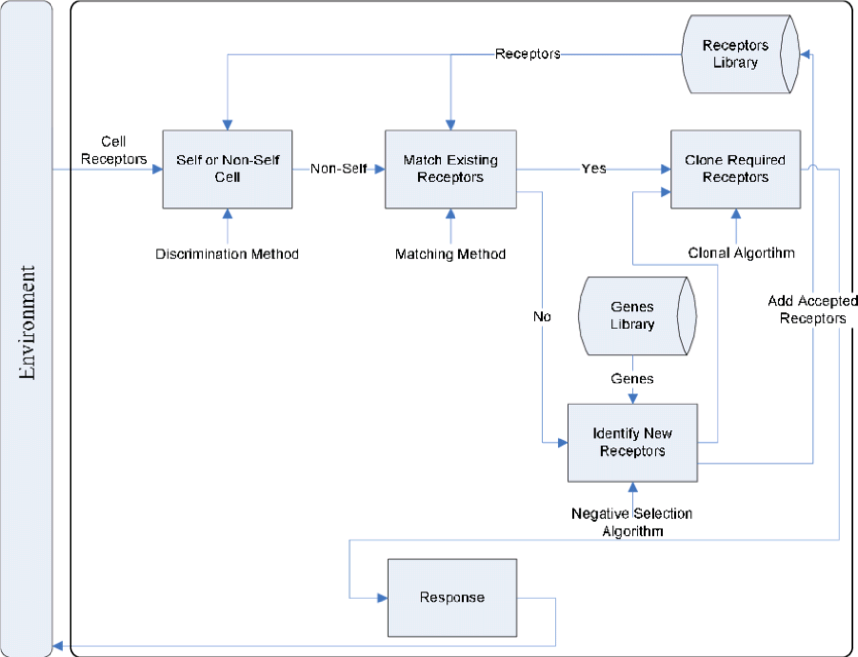

***Figure 3: SADT model***

**Some advantages of SADT Method are:**

* Its simplicity
* Its adequacy to capture the user's needs
* Its capacity with being able to produce solutions on several levels of abstraction.

**Some limits of SADT Method are:**

* Its analysis is concentrated much on the functions, the coherence of the data being neglected
* The rules of decomposition are not explicit. The decomposition differs according to analysts
* Its difficulties of taking account of the non-hierarchical interactions in the complex systems
* Lastly, the volatility of the functions makes that the system is in perpetual D-design

**3.11.2) MERISE METHOD**

The MERISE (Methode d’Etude et de Realisation Informatique pour les Systems d’Entreprise) method was launched around 1977 through a national consultation launched by the French Ministry of industry with the aim to create a company of data processing consultant in order to define a method of design of information system. The MERISE method is based on separation of data and treatments to be carried out in several conceptual and physical models. The MERISE method recommends three levels of abstraction; the conceptual level, the organizational level and the physical level.

**The conceptual level**: The conceptual level defines the finalities of the company. It is on this level that objectives to reach and constraints which weigh on the company are identified. It generally constitutes the most stable level and the first level of development. At the conceptual level, one distinguishes the Conceptual Data Model (CDM) and the Conceptual Treatments Model (CTM).

**The organizational or logical level:** The organizational level describes the organization which it is desirable to be set up in the company to achieve the laid down objectives. The purpose of it is to provide a diagrammatic representation of the organization of the company. One has heard of the Logical Data Model (LDM) and the Organizational Treatments Model (OTM). The organizational level is less stable and constitutes the second level of invariance.

**The physical level:** The physical level describes the means which will be implemented to manage the data and to activate the treatments. It is organized around the Physical Data Model (PDM) and the Operational Treatments Model (OTM).

Table 1: Representation of the levels of perception of MERISE

|  |  |  |
| --- | --- | --- |
| **Levels** | **Static (Data)** | **Dynamic (Treatments)** |
| **Conceptual** | CDM | CTM |
| **Physical** | PDM | OpTM |
| **Logical and Organizational** | DLM | OTM |

**Some advantages of MERISE method are:**

* MERISE is considered like a method of design of information systems on the plan of its general organization. For this reason, it has many advantages: 50
* MERISE allows the comprehension and the formalization of the needs for the trade
* MERISE supports the dialogue between originator and owner, building particularly in the projects of integrated system development of management.
* MERISE allows the general modelling of the data for construction of a database.
* MERISE ensures the formalization of the user's needs within the framework of a schedule of conditions, before the work of design.

**Some limitations of MERISE Method are**:

In spite of its many advantages, the MERISE method was often criticized as being a Franco-French historical method. Its disadvantages can be analyzed around three points:

* MERISE is more turned towards the engineering of general design than towards the software genius
* Difficulty in maintaining the system.
* Not easily evolutionary system.

**3.12) CHOICE OF METHOD**

Research on this work has presented: OMT, UML, UP, SADT and MERISE as some of the

principal models that can be used in designing an application. As a methodology to be used

in this work, UML has been chosen to design our application. Automatically, UML will use

the UP method because UP uses UML notations. The reason why UML is chosen is because

in UML, the dynamic (behavioral) and static (structural) things are fused into the system’s

entity to realize good and desirable results. This creates interdependency between the static

and the dynamic things. It also provides precision and stability of the system. Hence, it is

faster in building our application using the UML to MERISE method. The MERISE method

on the other hand, separates static approach system from the dynamic approach. It uses data

models in representing the static system and treatment models in representing the dynamic

system, it is not a method made specifically for software development like UML but rather, it

(MERISE) is generally used thus making the building of the application slower and costlier

because more materials are used to attain the same but less reliable result in quality and

quantity.

**3.13) APPLICATION OF UML METHOD**

As it is often said, a picture is worth a thousand words, this absolutely fits while discussing about

UML. UML is a pictorial standard and modeling mechanism for specifying, visualizing,

constructing, and documenting the artifacts of software systems. So beyond reasonable doubts,

UML will help us better realize our application and understand its functionality.

**3.13.1) ACTORS**

An actor is an external human or software agent closely to the system and interacts with that

system by its role played. In our case we have the following actors:

* **Administrator:** The administrator will be in charge of accepting and declining incoming projects from various customers and will also be in charge of assigning those projects to specific project teams that can handle the job.
* **Project Team (administrator):** The project team is in charge of accepting and declining incoming projects from various customers working on the project assigned to their dashboard by the administrator. They also keep in touch with the customers in order to better understand their needs in order to come out with a sophisticated end product which suits the clients.
* **Customer:** The customers are the main actors of our system. They are the primary reason why the system is built in the first place. These are the people who bring projects to the company to be done.
* **Tracking Records:** All the customer needs and complaints transmitted through the website will be saved here.
* **Technical Support Staff:** These are the actors who are in charge of handling any technical issues that may occur on the website. They also follow up with the project team and help them manage projects.
* **Marketing professionals:** These are the actors in charge of the front end of the website. The marketing professionals receive pictures and updates from the technical support staff and the project team and then uploads them on the web application such that the customers can log in and see their project’s progress.

**3.13.2) DIAGRAMS**

1. **The Sequence diagram**

The sequence diagram as one of the interactions over view diagrams, emphasizes on time sequences of message flow from one object to another. The sequence diagrams are a type of Unified Modeling Language (UML). They are used to show how objects in a system work together over time. A sequence diagram helps the designer of the system visualize and understand the order in which these interactions occur.

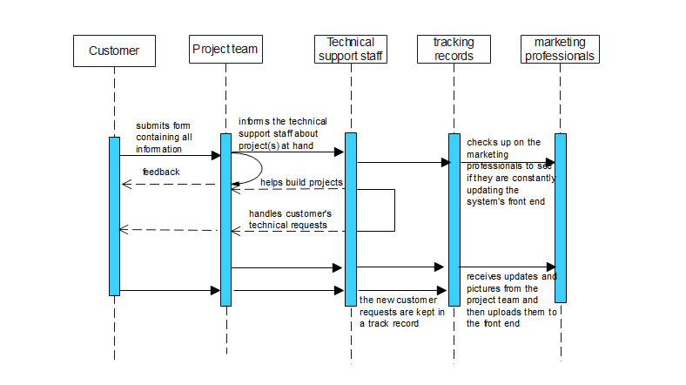

***Figure 4: sequence diagram***

1. **Class diagram:**

The class diagram is a static diagram. It represents the static view of an application. So, a

collection of class diagrams represents the whole system. Class diagram is not only used for

visualizing, describing and documenting different aspects of system but also for constructing

executable code of the software application.

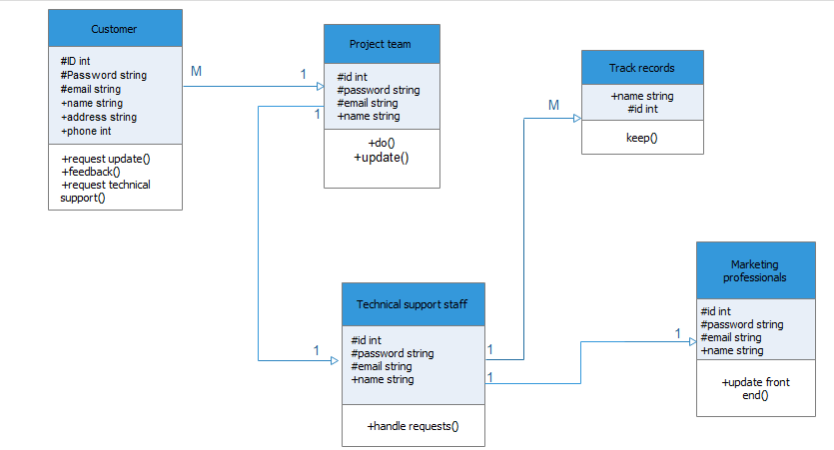

***Figure 5: class diagram***

The class in figure 5 above shows all the entities of the CRM and their respective attributes. The relationship that exists between one or more entities (tables) can be clearly seen from the lines linking the individual tables and the nature in which they are related can be seen from the cardinality of different tables. As seen, a single Project team can handle multiple clients at the same time, multiple tracking records can be updated by a single technical support staff, one technical support staff can work with a single project team, one technical support staff can work with one marketing professional.

1. **Use Case diagram:**

The use case diagram is one which clearly shows all the actors in a given system and how those said actors interact with that system. This part contains the analysis of the functional and non-functional requirements using use case diagram and use case details

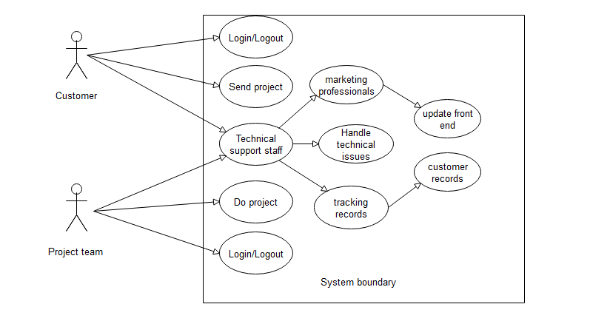

***Figure 6: Use Case diagram***

From the diagram above, the project team can login and logout, work on projects sent by the customers, with the assistance of the technical support staff where the technical support staff supervises the marketing professionals in order to make sure that they are constantly updating the front end of the system with pictures of the project so that the customer will be able to see his or her progress. The technical support staff is also in charge of handling the tracking records which contains all the customer complaints based on the project and the pictures being updated by the marketing professionals.

**COMPONENTS OF THE SYSTEM**

The components of the system include modules which can be viewed on the result management system platform. The various components present in the system include:

**Login process into the system:** This module contains four main functions;

* **Project team sign in:** This function is meant for the administrator of the system
* **User sign in:** This function is meant for the other members of the platform to be able to access the system, that is, **the technical support staff, customers, and the marketing professionals.**

**3.14)** **VARIOUS MODEL OF THE METHOD**

**3.14.1.1) DATA DICTIONARY**

|  |  |  |  |  |
| --- | --- | --- | --- | --- |
| No | Reference | Significance | Type | Size |
|  |  |  |  |  |
|  |  |  |  |  |
|  |  |  |  |  |
|  |  |  |  |  |
|  |  |  |  |  |
|  |  |  |  |  |
|  |  |  |  |  |